Student Name: __________________
Class and Section __________________
Total Points (20 pts) __________________
Due: Wednesday Oct 6, 2010 before the class

Final Project: Displaying Regular Polygons

CSCI 1302 Advanced Programming Principles
Armstrong Atlantic State University

Problem Description:

Create a subclass of JPane, named RegularPolygonPane, to paint an n-sided regular polygon. The class contains a property named numberOfSides, which specifies the number of sides in the polygon. The polygon is centered at the center of the Pane. The size of the polygon is proportional to the size of the Pane. Create a pentagon, hexagon, heptagon, and octagon, nonagon, and decagon from RegularPolygonPane and display them in a frame, as shown in the figure below.

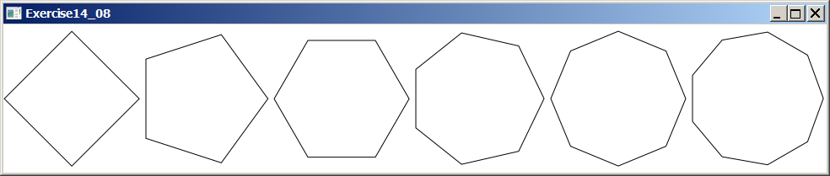

Your Task:
- Define a class named RegularPolygonPane to paint an n-sided regular polygon. (So, if n is 3, it paints a triangle, if n is 4, it paints a square, etc.)
- Create a frame classes that contains pentagon, hexagon, heptagon, and octagon, nonagon, and decagon. These objects are created from RegularPolygonPane.
- Draw a UML diagram for RegularPolygonPane class and the frame class.

Your Code:
Name your program Exercise14_08Extra and copy the code here.

Screen shots:
Include a screen shot here:

Submit the following items:

1. Compile and Submit to LiveLab (you must submit the program regardless whether it complete or incomplete, correct or incorrect)

2. Fill in self-evaluation:

- Can your program create the UI? _______________
- Can your program display polygons correctly?

